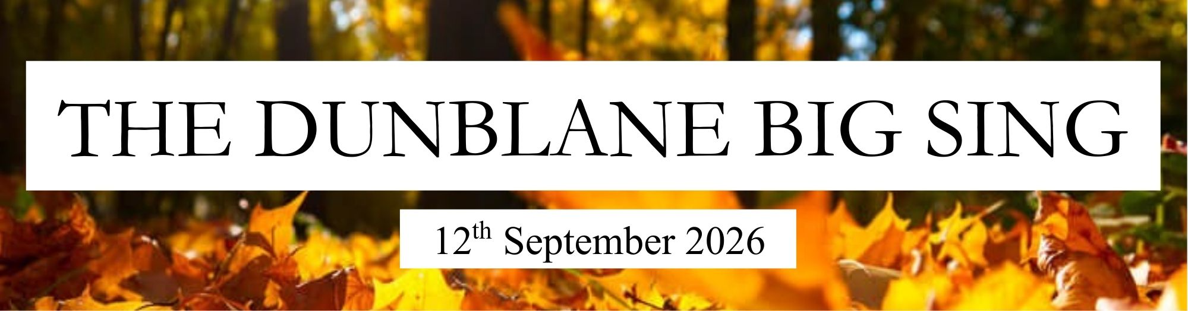

BOOKING FORM

Name: |  |  |  | 18+: |  | YES / NO
Address:
Contact Number: |  |  |  | Email:
Emergency Contact:
(Name and Number)
Dietary Requirements/ Allergies:
Any further info or comments?
Do you give permission for your photo to be taken and  possibly used in further publicity for The Dunblane Big Sing |  |  |  |  | YES / NO
How did you hear about the Dunblane Big Sing?
Voice Type  :  (if known) | [i.e. HIGH • MIDDLE • LOW • MELODY ONLY • BASS • TENOR • ALTO • SOPRANO • ANY...]
Singing Group(s):
(if applicable)
Song Suggestions: If you have sung with me before and there are songs you’d like to revisit on the day to hear them sung in a big group – please list them below: (or any other songs you fancy having a crack at – I always like song suggestions!)
Would you/your group like to sing at the Performance space?

Please return this booking form by email attachment or by post (address available on request).
Once you have confirmation that your form has been received, your place at the song day is secured by paying the £35 balance via the paypal link on the web page or bank transfer to the account below. Please use your name as a reference. Bank transfer means no fees are incurred by my small business (receipts are available). If bank transfer is not possible, there is the option to pay using PayPal for those who need or prefer to pay by that method.

Amy Lord HSBC sort code: 40-41-60 Account No: 20045985

Any further questions or queries, please contact Amy
07776 138 674 or dunblanebigsing@gmail.com

